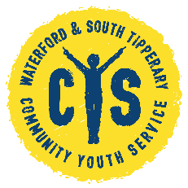 Waterford & South Tipperary Community Youth Service

Youth Employability Pathways Contact Form

Name (Mr/Mrs/Ms):
Gender: Male Female Prefer not to say
Address:
Tel No:
Date of Birth
Place of birth:

Do you suffer from any illness / disability / medical condition which may at times affect your ability to engage in the project? If so please give details:

Which area would you like to attend? Waterford, Dungarvan or Clonmel?

Do you consent to being contact via phone? Yes No

